**01-IntroductiontoPython-Variables-DatatypesInput/Output-Formatting**

**Ex.No. : 1.1 Date:**

**RegisterNo.: 231501070 Name: Kaaleeswaran v**

## [ConvertingInputStrings](https://www.rajalakshmicolleges.net/moodle/mod/quiz/view.php?id=6373)

Writeaprogramtoconvertstringstoanintegerandfloatanddisplayitstype.

*SampleOutput:*10,<class 'int'>10.9,<class'float'>

**Forexample:**

|  |  |
| --- | --- |
| **Input** | **Result** |
| 10  10.9 | 10,<class'int'>10.9,<class'float'> |

Program:a=input()b=input()

c=int(a)d=float(b)

print(c,type(c),sep=",")

print("{:0.1f}".format(d),type(d),sep=",")

# Output:

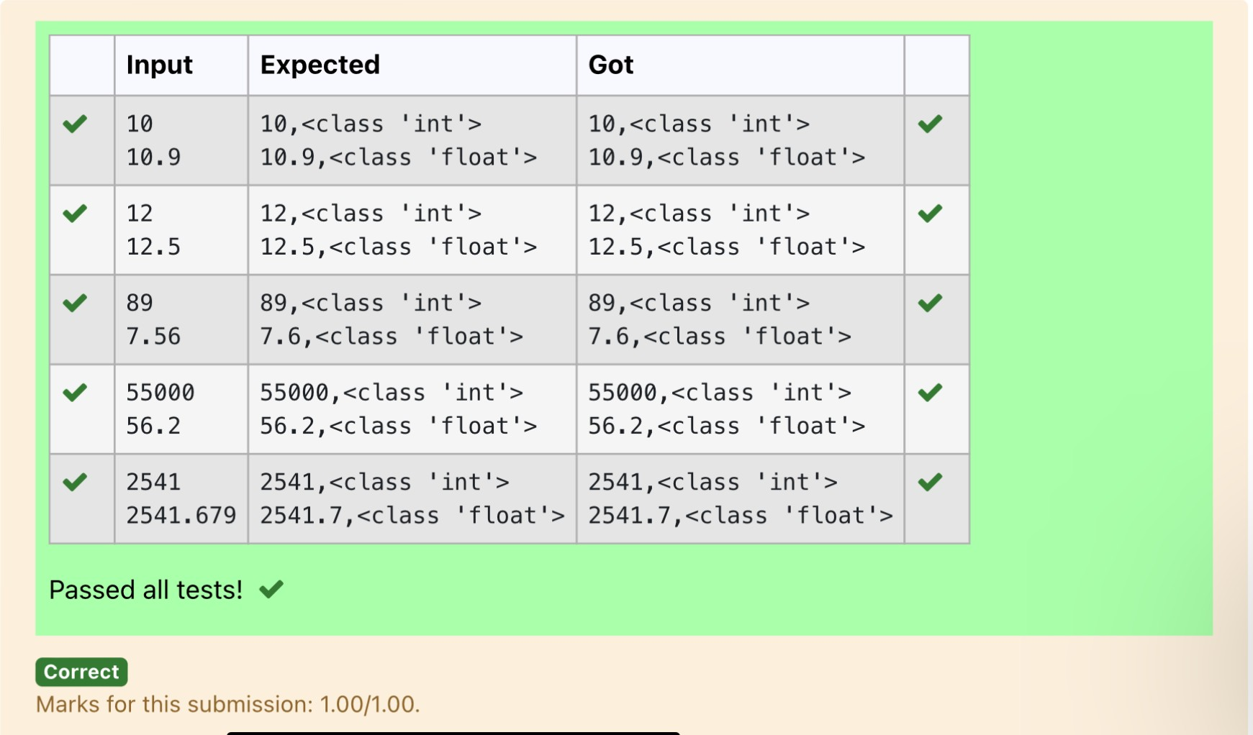

**Ex.No. : 1.2 Date:**

**RegisterNo.: Name:**

## [GrossSalary](https://www.rajalakshmicolleges.net/moodle/mod/quiz/view.php?id=6374)

Ramesh’s basic salary is input through the keyboard. His dearness allowance is40% of his basic salary, and his house rent allowance is 20% of his basic salary.Writeaprogramtocalculatehisgrosssalary.

*SampleInput:*

10000

*SampleOutput:*

16000

**Forexample:**

|  |  |
| --- | --- |
| **Input** | **Result** |
| 10000 | 16000 |

# Program:

s=int(input())da=s*0.4ha=s*0.2

print(int(s+da+ha))

# Output:

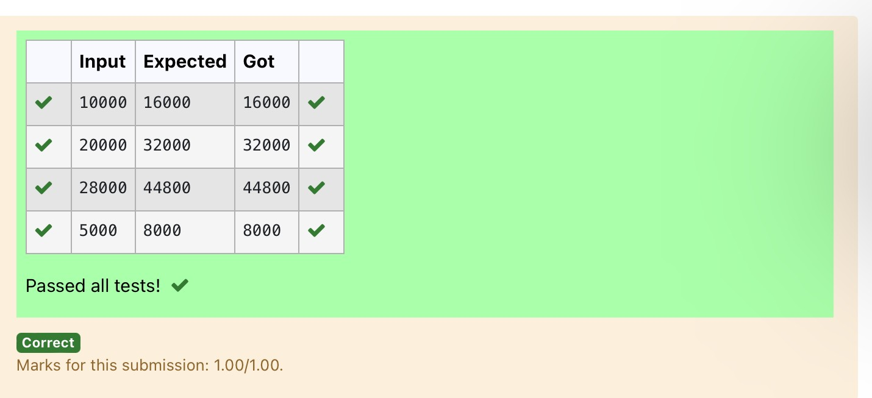

**Ex.No. : 1.3 Date:**

**RegisterNo.: Name:**

## SquareRoot

Writeasimplepythonprogramtofindthesquarerootofagivenfloatingpointnumber.Theoutputshouldbedisplayedwith3decimal places.

SampleInput:8.00

SampleOutput:2.828

**Forexample:**

|  |  |
| --- | --- |
| **Input** | **Result** |
| 14.00 | 3.742 |

# Program:

importmatha=float(input())s=math.sqrt(a)print("{:.3f}".format(s))

# Output:

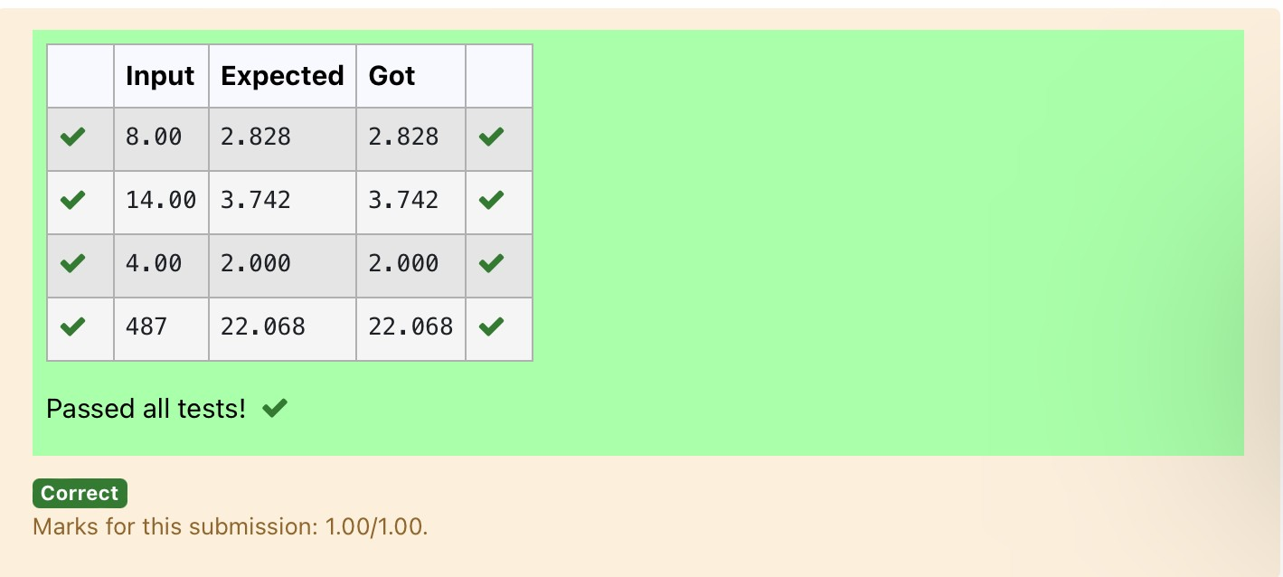

**Ex.No. : 1.4 Date:**

**RegisterNo.: Name:**

## [Gainpercent](https://www.rajalakshmicolleges.net/moodle/mod/quiz/view.php?id=6376)

Alfred buys an old scooter for Rs. X and spends Rs. Y on its repairs. If he sells thescooter for Rs. Z (Z>X+Y). Write a program to help Alfred to find his gain percent.Getalltheabove-mentionedvaluesthroughthekeyboardand find the gainpercent.

Input Format:

ThefirstlinecontainstheRsXThe second line contains Rs YThethirdlinecontainsRsZSampleInput:

10000

250

15000

SampleOutput:

46.34isthegainpercent.

**Forexample:**

|  |  |
| --- | --- |
| **Input** | **Result** |
| 45500  500  60000 | 30.43isthegainpercent. |

# Program:

buys=int(input())

repair=int(input())sells=int(input())

g=(((sells-(buys+repair))/(buys+repair))*100) print("{:.2f}".format(g),"isthegainpercent.")

# Output:

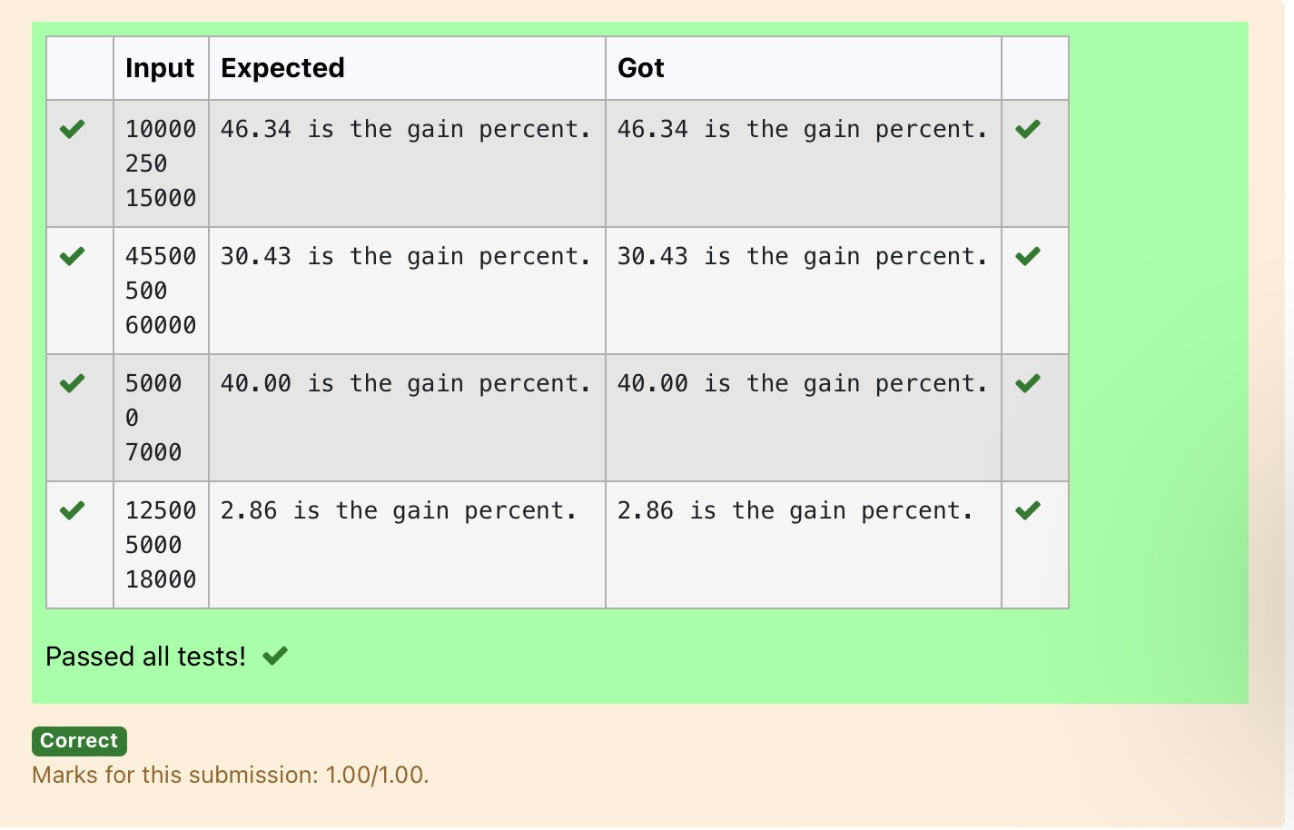

**Ex.No. : 1.5 Date:**

**RegisterNo.: Name:**

## [Deposits](https://www.rajalakshmicolleges.net/moodle/mod/quiz/view.php?id=6378)

In many jurisdictions, a small deposit is added to drink containers to encouragepeople to recycle them. In one particular jurisdiction, drink containers holding oneliterorlesshavea$0.10depositanddrinkcontainersholdingmorethanoneliterhave a $0.25 deposit. Write a program that reads the number of containers of eachsize(less and more) from the user. Your program should continue by computingand displaying the refund that will be received for returning those containers.Format the output so that it includes a dollar sign and always displays exactly twodecimalplaces.

SampleInput10

20

SampleOutput

Yourtotalrefundwillbe$6.00.

**Forexample:**

|  |  |
| --- | --- |
| **Input** | **Result** |
| 20  20 | Yourtotalrefundwillbe$7.00. |

# Program:

a=int(input())b=int(input())c=a*0.1d=b*0.25e=c+d

print("Yourtotalrefundwillbe${:.2f}.".format(e))

# Output:

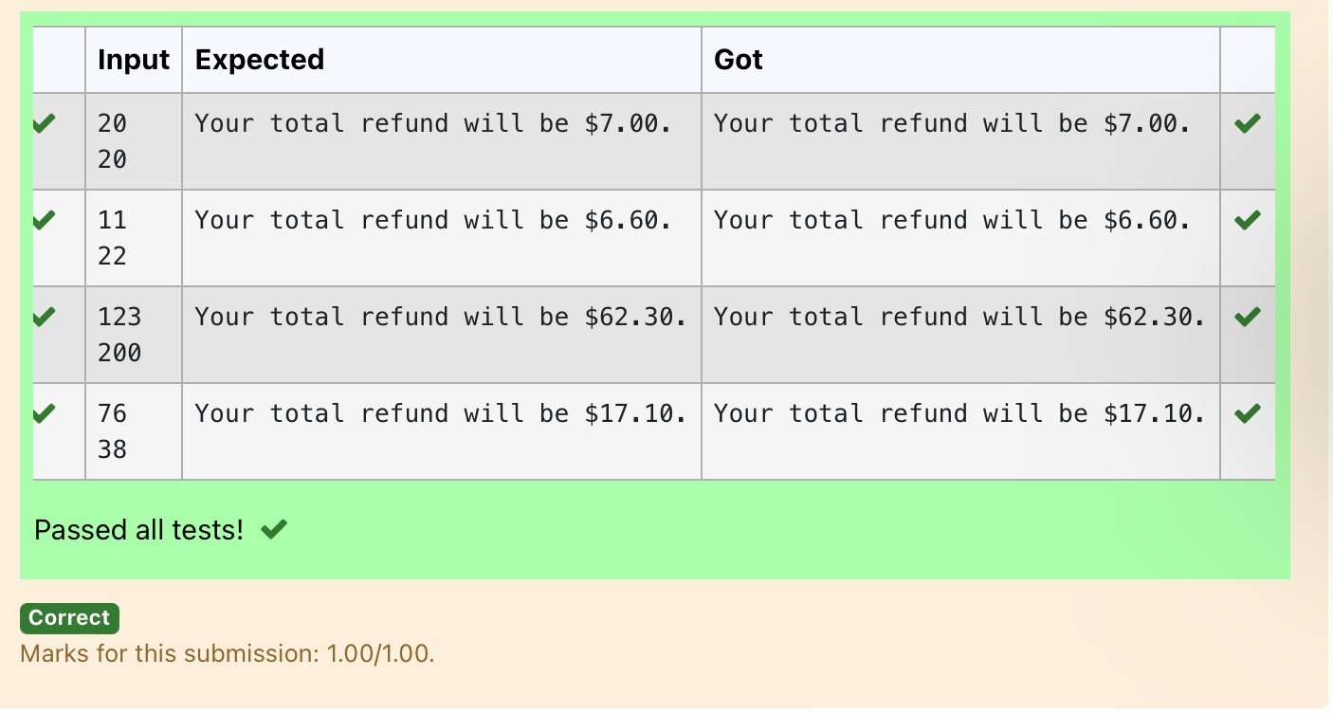

**Ex.No. : 1.6 Date:**

**RegisterNo.: Name:**

## [Carpenter](https://www.rajalakshmicolleges.net/moodle/mod/quiz/view.php?id=6379)

Justin is a carpenter who works on an hourly basis. He works in a company wherehe is paid Rs 50 for an hour on weekdays and Rs 80 for an hour on weekends. Heworks 10 hrs more on weekdays than weekends. If the salary paid for him is given,write a program to find the number of hours he has worked on weekdays andweekends.

**Hint:**

Ifthefinalresult(hrs)arein-veconvertthatto+veusingabs()functionTheabs()functionreturnstheabsolutevalueofthegivennumber.

number=-20

absolute_number=abs(number)print(absolute_number)

#Output:20

**SampleInput:**

450

**SampleOutput:**

weekdays10.38

weekend0.38

**Forexample:**

|  |  |
| --- | --- |
| **Input** | **Result** |
| 450 | weekdays10.38  weekend0.38 |

# Program:

s=int(input())a=(500-s)/130

print("weekdays{:.2f}".format(abs(a)+10))

print("weekend{:.2f}".format(abs(a)))

# Output:

